ImageMedix: Dual-Stage Medical Image Diagnosis Using Deep Learning

Vaishnavi Chandrasekar∗, Christiana Heden Kothuru∗, Deepika Mothkuri∗,

Greeshma Kenche∗, Yucong Hu∗, Lingyi Luan∗,

Yash Bhanubhai Panchani∗, Rameez Ahmed Shaik∗

∗Department of Computer Science, Pace University, New York, NY, USA

*Abstract*—This paper presents ImageMedix, an intelligent medical image analysis system developed to classify lung X-rays and brain MRIs using a dual-stage deep learning approach. The application addresses the delay in diagnosis and high workload on healthcare professionals by automating image classification and displaying preliminary diagnostic results. Utilizing a sprintbased development approach, the project incorporates machine learning, frontend-backend integration, and ethical AI practices.

*Index Terms*—Deep Learning, CNN, Medical Imaging, Xray, MRI, AI in Healthcare, Image Classification, Pneumonia Detection, Tumor Detection, Flask API, ReactJS, Full-Stack Development.

# I. INTRODUCTION

Medical imaging has become a cornerstone in modern healthcare for diagnosing a variety of conditions ranging from respiratory illnesses to neurological disorders. However, traditional diagnostic workflows are time-consuming, highly dependent on expert availability, and susceptible to human error due to fatigue or workload. With the increasing global demand for healthcare services and the shortage of radiologists, it is critical to integrate artificial intelligence into diagnostic processes to improve accuracy, reduce diagnosis time, and alleviate stress on medical staff.

ImageMedix was developed with these objectives in mind. It is an AI-powered diagnostic platform capable of analyzing two distinct types of medical images—lung X-rays and brain MRIs. This dual-stage system provides real-time analysis and classification, enabling healthcare professionals to make faster and more informed decisions. The tool also integrates rolebased access and secure authentication, ensuring personalized data access for patients and clinicians.

# II. PROBLEM STATEMENT

The healthcare industry continues to face serious challenges in the timely and accurate diagnosis of diseases like pneumonia and brain tumors. These conditions require specialized image interpretation, which is often delayed due to:

* Limited access to expert radiologists, especially in remote and underserved regions.
* Separate systems and tools for different imaging modalities, increasing workflow complexity.
* High patient volumes that overwhelm existing diagnostic infrastructure.

These inefficiencies can result in delayed treatments, misdiagnoses, and ultimately poorer patient outcomes. Current systems are not equipped to integrate diverse image types within a single platform or provide automated diagnostic insights. There is a pressing need for a unified, automated solution that streamlines diagnosis, integrates dual-image processing, and ensures secure patient data management. ImageMedix is proposed as such a solution.

# III. LITERATURE REVIEW

Artificial Intelligence, especially deep learning, has shown transformative potential in medical image analysis. Studies leveraging Convolutional Neural Networks (CNNs) for classifying chest X-rays and brain MRIs have reported high accuracy, often exceeding 90%. For instance, CheXNet, developed using the CheXpert dataset, reached radiologist-level performance in pneumonia detection. Similarly, CNN architectures like VGG16 and DenseNet have demonstrated success in detecting brain tumors from MRIs.

The availability of large-scale datasets such as CheXpert for chest X-rays and multiple annotated brain MRI datasets has significantly contributed to the advancement of machine learning in diagnostics. However, most research projects focus on a single modality, such as lung or brain images, and few attempt to integrate both.

Another significant challenge discussed in the literature is the real-world application of these models. Issues such as dataset bias, lack of transparency in AI decisions, and integration with clinical workflows are commonly cited. Ethical AI, including fair data representation and role-based access, remains a crucial area for safe deployment in healthcare.

ImageMedix seeks to bridge these gaps by delivering a dualstage diagnostic tool, incorporating explainable AI principles and agile development methodologies, thereby making strides toward practical clinical integration.

# IV. PROJECT DESCRIPTION

ImageMedix is a full-stack web-based diagnostic platform designed to classify lung X-rays and brain MRIs with high accuracy. The project follows agile development principles, completed across three primary sprints. Each sprint introduced critical system capabilities, starting from UI setup to full backend integration and AI model deployment.

In Sprint 1, the focus was on the frontend development including navigation menus, static page rendering, and upload UI. Sprint 2 introduced machine learning model integration using Flask APIs, enabling real-time predictions for uploaded images and storing the results in a cloud database. Sprint 3 added role-based user authentication, diagnosis history tracking, and PDF report generation.

The solution aims to assist healthcare workers by providing rapid diagnostics and streamlining patient interactions via a clean and intuitive user interface.

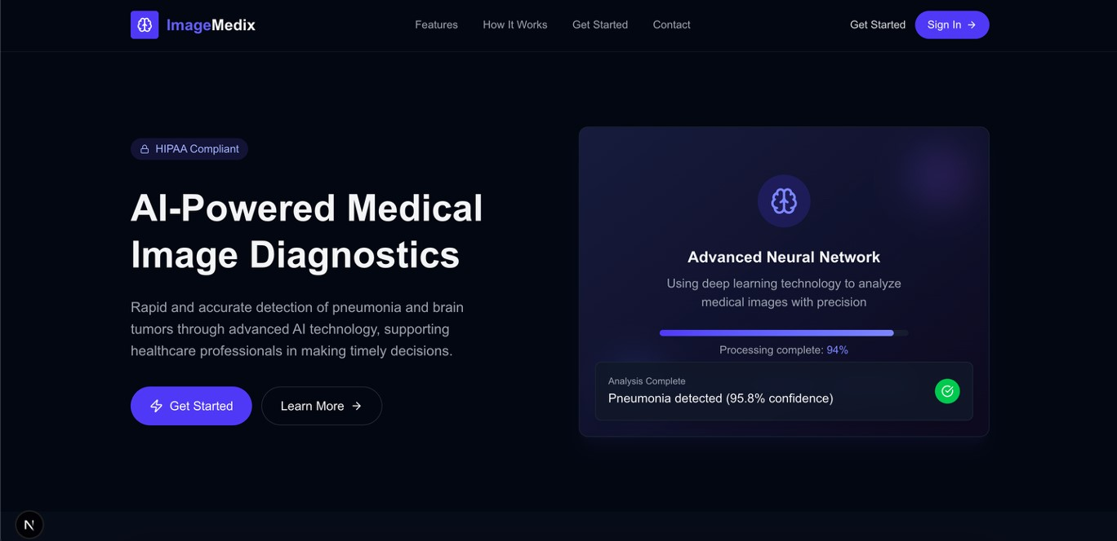

Fig. 1. ImageMedix Homepage showcasing AI-powered medical diagnostic interface.

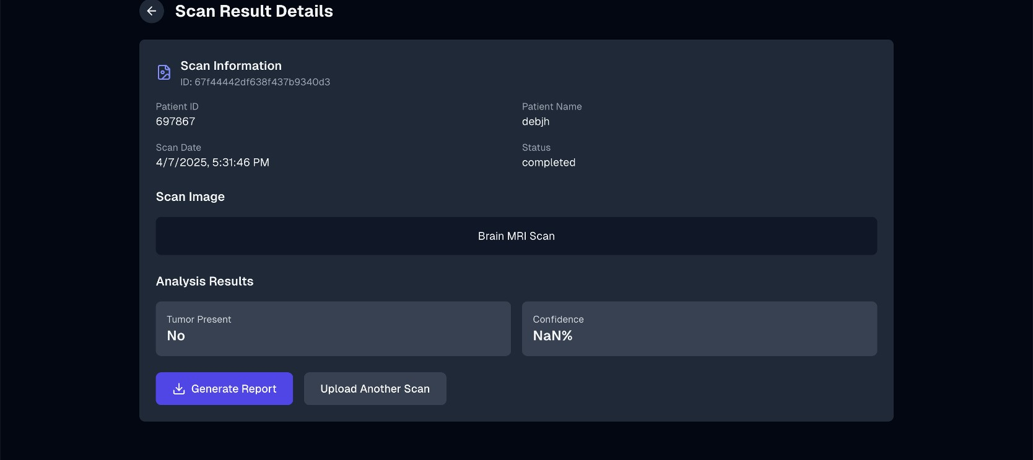

Fig. 2. Brain MRI diagnostic result screen with tumor classification and report generation.

# V. SYSTEM ARCHITECTURE

The architecture of ImageMedix is modular, scalable, and designed to support real-time diagnostics across different medical image modalities. The system follows a client-server architecture and integrates key components such as a ReactJS frontend, Flask backend, pre-trained AI models, and cloud storage. Each module is responsible for a specific task in the diagnostic pipeline, enabling efficient data flow and easy extensibility.

## A. Frontend

The frontend is developed using ReactJS, a widely adopted JavaScript library for building interactive user interfaces. React’s component-based architecture ensures modularity, ease of maintenance, and reusability across the platform. The frontend serves as the primary access point for both doctors and patients and is optimized for accessibility across devices. It includes:

* A responsive navigation bar providing seamless access to main sections: *Home*, *Upload*, *Results*, and *About*.
* An image upload interface supporting drag-and-drop and manual selection, with preview capability to confirm correct image before submission.
* A diagnostic result display card showing model predictions, classification label, and associated confidence score. Visual elements such as status indicators and dynamic feedback are included for enhanced usability.
* Secure authentication pages, featuring encrypted login and registration mechanisms, supporting role-based access for medical professionals and patients.
* Form validation, error handling, and loading indicators to guide user actions and provide real-time feedback.

React Router is used for client-side routing, and the frontend consumes backend APIs asynchronously using Axios, enabling real-time interactions without page reloads.

## B. Backend

The backend is developed using Flask, a lightweight and flexible Python-based web framework that facilitates rapid development and integration of AI models. It acts as the core logic engine of ImageMedix, orchestrating communication between the frontend, machine learning models, and database. Key responsibilities include:

* Handling RESTful API endpoints for image upload, preprocessing, inference calls, result retrieval, and report generation.
* Invoking the correct model pipeline after classifying the image type and returning inference results in JSON format to the frontend.
* Managing user sessions through JWT (JSON Web Tokens), supporting secure role-based access and authorization for doctors and patients.
* Interfacing with the cloud database to store and retrieve user data, image metadata, prediction results, and report histories.
* Supporting asynchronous task execution and scalability via potential integration with tools like Celery and Redis (in future development).

## C. Machine Learning Model

The diagnostic engine of ImageMedix consists of a dualstage classification pipeline using Convolutional Neural Networks (CNNs):

* Stage 1 – Image Type Classifier: A fine-tuned ResNet model classifies the input image as either a chest X-ray or a brain MRI. This automated routing mechanism ensures that each image follows the correct preprocessing and analysis pipeline.
* Stage 2 – Modality-Specific Diagnosis:
  + Model 1 – Lung X-rays: Built on EfficientNet architecture and trained on the CheXpert dataset, this model detects pneumonia and classifies it into *Normal*, *Viral Pneumonia*, or *Bacterial Pneumonia*. Preprocessing includes grayscale normalization, histogram equalization, and noise reduction.
  + Model 2 – Brain MRIs: Also based on EfficientNet and trained using public datasets such as BraTS and Kaggle repositories, this model classifies MRIs as *Glioma*, *Meningioma*, or *No Tumor*. Preprocessing involves skull stripping, contrast enhancement, and slice selection.

The models use dropout layers and data augmentation to avoid overfitting and are validated with stratified crossvalidation techniques. Grad-CAM heatmaps are generated for explainability and visual interpretability, especially for clinical decision-making support.

## D. Database

A secure, cloud-hosted relational database (e.g., PostgreSQL) forms the backbone of ImageMedix’s data storage layer. It ensures data persistence, retrieval efficiency, and adherence to security and compliance standards.

The database schema supports:

* Storage of user credentials, roles (e.g., Doctor, Patient), and access logs for audit trails.
* Saving of uploaded images in binary format or as links to cloud storage (e.g., AWS S3 or Firebase), along with metadata such as scan type, timestamps, and diagnosis result.
* Logging of diagnostic history per user, enabling longitudinal review and report regeneration.
* Indexing and relational mapping for optimized search, retrieval, and analytics queries.

Advanced security measures such as data encryption (at rest and in transit), prepared SQL statements to prevent injection attacks, and access control via role-based policies are implemented to ensure patient confidentiality and HIPAA compliance.

## E. Architecture Flow

The overall architecture ensures modularity and robustness by clearly separating concerns between UI, processing, inference, and storage. Figure 3 illustrates the high-level system interaction:

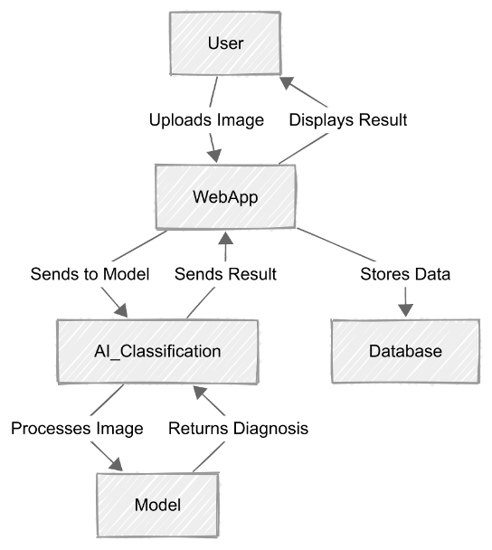

Fig. 3. System Architecture Diagram of ImageMedix showing component interaction and data flow from user to AI model and database.

As seen, the user interacts with the web application by uploading a medical image. This image is routed to the AI Classification module, which selects and forwards the image to the correct model. After diagnosis, the result is stored in the database and returned to the web frontend for display.

## F. Sequence Diagram

The following sequence diagram (Figure 4) details the temporal flow of interactions between system components during a diagnostic session:

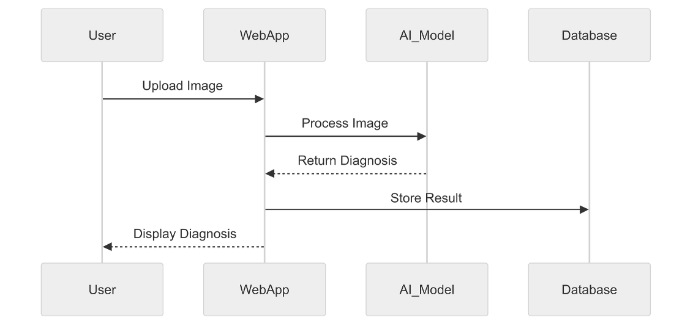

Fig. 4. Sequence Diagram of ImageMedix illustrating the order of operations between user, web app, AI model, and database.

The process begins when a user uploads an image through the web interface. The image is then transmitted to the AI Model module, which processes it and returns a diagnosis. This diagnosis is subsequently stored in the database. Finally, the web app displays the result to the user. This sequence ensures a synchronous and seamless experience, maintaining system responsiveness and reliability.

# VI. ALGORITHMS

The ImageMedix system employs a dual-stage algorithmic pipeline built on pre-trained deep learning models to perform accurate and efficient diagnosis of medical images. This system intelligently identifies the type of input image—either a lung X-ray or a brain MRI—and processes it through specialized models optimized for each modality.

## A. Stage 1: Image Type Classification

A modified ResNet architecture, fine-tuned on a custom medical image dataset, serves as the initial classifier to determine whether the uploaded image is a chest X-ray or a brain MRI. This enables the platform to route the image to the appropriate diagnostic model in the second stage, ensuring correct preprocessing and interpretation paths.

## B. Stage 2: Modality-Specific Diagnosis

Once the image type is determined, it is passed to one of two fine-tuned EfficientNet models optimized for specific diagnostic tasks:

* Lung X-rays (Pneumonia Detection): The system uses a fine-tuned EfficientNet model to analyze chest X-rays. It classifies the images into three categories: *Normal*, *Viral Pneumonia*, and *Bacterial Pneumonia*. The model was trained using the CheXpert dataset, with additional preprocessing such as contrast enhancement and normalization to highlight lung features. Feature maps are generated and analyzed for pattern detection in lung regions, significantly aiding in diagnostic confidence.
* Brain MRIs (Tumor Classification): For MRI scans, the same EfficientNet architecture is used but trained on annotated datasets from Kaggle and other open-source repositories. The model identifies the presence of brain tumors and further classifies them into subtypes such as *Glioma*, *Meningioma*, or *No Tumor*. The classification is based on structural anomalies in the brain tissue, and the model is optimized for sensitivity to subtle differences in grayscale MRI slices.

## C. Model Efficiency and Accuracy

Both models leverage the inherent efficiency of EfficientNet’s compound scaling, which balances depth, width, and resolution for high accuracy with fewer parameters. This allows real-time inference even on resource-constrained environments. Dropout regularization, data augmentation, and cross-validation were employed to prevent overfitting and ensure generalizability.

## D. Explainable AI Integration

To enhance trust and transparency, Grad-CAM visualizations are integrated into the prediction results. These heatmaps highlight regions of the input image that contributed most to the classification decision, allowing users and clinicians to visually interpret the model’s reasoning.

# VII. USER STORIES AND SPRINTS

The development of ImageMedix followed an agile methodology structured into three main sprints, each focused on delivering core features incrementally based on user needs and technical feasibility. The user stories were framed around two key personas: a medical professional seeking rapid diagnostics and a patient accessing personal reports.

Sprint 1: User Interface and Structure

* Designed and implemented a responsive landing page presenting the project overview and core objectives.
* Built a functional navigation bar with routing using React Router, enabling smooth transitions between views such as Home, Upload, Results, and About.
* Developed an image upload interface to allow users to select and preview medical images. This sprint focused solely on frontend functionality to establish a solid user experience baseline.

Sprint 2: Backend Integration and Model Inference

* Integrated Flask-based RESTful APIs to connect the frontend upload module with the backend inference engine.
* Implemented logic to save uploaded images and corresponding predictions to a cloud-hosted relational database for retrieval and history tracking.
* Developed a secure authentication module using JSON Web Tokens (JWT) to manage login, signup, and user sessions with role-based access controls for doctors and patients.

Sprint 3: Final Features and Deployment

* Enabled automatic generation and download of detailed PDF diagnosis reports that include image previews, classification results, and model confidence scores.
* Deployed the web application on cloud services (e.g., Render, Netlify) ensuring cross-platform accessibility and performance optimization.
* Conducted fine-tuning of machine learning models, improving accuracy and reducing latency for real-time usage.

# VIII. EVALUATION

The performance of the ImageMedix system was evaluated using standard classification metrics including Accuracy, Precision, Recall, and F1-Score. These metrics were computed on separate test datasets that were never seen during training to ensure fair evaluation.

Model Evaluation Metrics:

* Accuracy: Measures the overall correctness of the model predictions.
* Precision: Indicates the proportion of true positives among all positive predictions.
* Recall: Reflects the model’s ability to identify all relevant instances (sensitivity).
* F1-Score: Harmonic mean of precision and recall, balancing false positives and false negatives.

Quantitative Results:

* Lung X-ray (Pneumonia Detection): Accuracy: 92%, F1-Score: 0.89
* Brain MRI (Tumor Detection): Accuracy: 91%, F1Score: 0.90

These metrics validate the system’s reliability for assisting medical professionals in preliminary diagnosis.

# IX. ETHICAL CONSIDERATIONS

In deploying AI within healthcare, ethical principles are of paramount importance. ImageMedix incorporates several mechanisms to ensure responsible and fair usage:

* Fairness: The models are trained on balanced datasets to mitigate bias across age, gender, and ethnicity. Data sampling techniques were applied to avoid overrepresentation of any particular class.
* Privacy: All patient data is securely stored and encrypted both in transit and at rest. User authentication ensures that sensitive diagnosis results are only accessible to authorized individuals.
* Transparency: The platform includes explainable AI features such as Grad-CAM heatmaps to offer interpretability for each prediction, supporting clinical validation and building trust in AI-assisted decisions.

# X. CHALLENGES AND LIMITATIONS

While ImageMedix demonstrates strong potential, several limitations were identified during development and testing:

* Generalizability: The models may not generalize well across different hospitals or imaging equipment due to variations in image quality, resolution, and protocols. Cross-institutional validation is needed.
* Device Performance: Real-time model inference may experience latency on low-resource devices such as older smartphones or underpowered systems, limiting accessibility in rural clinics.
* Dataset Bias and Validation: Despite dataset balancing, potential biases remain due to limited diversity in training data. Furthermore, the models require formal clinical validation before being adopted in real-world medical settings.

# XI. CONCLUSION

ImageMedix offers a comprehensive, scalable, and intelligent solution for dual-modality medical image classification, combining state-of-the-art deep learning models with an intuitive web-based interface. By integrating EfficientNet architectures for pneumonia and brain tumor detection, the system achieves high diagnostic accuracy while maintaining accessibility and ease of use across platforms. The dual-stage inference pipeline, supported by explainable AI and robust backend infrastructure, provides a reliable decision support tool for clinicians, especially in settings with limited access to expert radiologists.

The platform also incorporates ethical AI practices, including privacy preservation, dataset fairness, and transparency, making it a responsible step forward in the deployment of AI in healthcare. The agile sprint-based development ensured rapid prototyping, testing, and deployment of essential features ranging from image uploads and real-time predictions to downloadable reports and secure user management.

Future work involves extending the current binary and ternary classification capabilities to multi-label diagnosis, where a single image might indicate multiple conditions. Additionally, plans include the integration of a real-time chat interface for direct communication between patients and healthcare providers, deeper clinical validation in collaboration with medical institutions, and expansion to support other image modalities such as CT scans or ultrasound. With continuous refinement, ImageMedix aims to become a versatile and impactful clinical decision support system in modern digital healthcare ecosystems.

# REFERENCES

1. J. Irvin et al., “CheXpert: A Large Chest Radiograph Dataset with Uncertainty Labels,” *arXiv preprint arXiv:1901.07031*, 2019.
2. J. Cheng et al., “Enhanced Performance of Brain Tumor Classification via Tumor Region Augmentation and Partition,” *Computers in Biology and Medicine*, vol. 67, pp. 8–17, 2015.
3. P. Rajpurkar et al., “CheXNet: Radiologist-Level Pneumonia Detection on Chest X-Rays with Deep Learning,” *arXiv preprint arXiv:1711.05225*, 2017.
4. M. Grinberg, *Flask Web Development*, 2nd ed., O’Reilly Media, 2018.
5. D. Abramov and React Team, “Getting Started with React,” *Facebook Open Source Docs*, 2021.
6. G. Litjens et al., “A Survey on Deep Learning in Medical Image Analysis,” *Medical Image Analysis*, vol. 42, pp. 60–88, 2017.
7. M. Tan and Q. Le, “EfficientNet: Rethinking Model Scaling for Convolutional Neural Networks,” *ICML*, 2019.
8. R. R. Selvaraju et al., “Grad-CAM: Visual Explanations from Deep Networks via Gradient-Based Localization,” *IJCV*, vol. 128, pp. 336– 359, 2020.
9. B. Mittelstadt et al., “The Ethics of Algorithms: Mapping the Debate,” *Big Data & Society*, vol. 3, no. 2, pp. 1–21, 2016.
10. M. Esteva et al., “A Guide to Deep Learning in Healthcare,” *Nature Medicine*, vol. 25, pp. 24–29, 2019.
11. S. Oakden-Rayner, “Exploring Large-Scale Public Medical Image Datasets,” *Academic Radiology*, vol. 27, no. 1, pp. 106–112, 2020.
12. I. Char et al., “Implementing AI in Healthcare—Ethical and Legal Challenges,” *New England Journal of Medicine*, vol. 378, pp. 981–983, 2018.
13. H. Rieke et al., “The Future of Digital Health with Federated Learning,” *npj Digital Medicine*, vol. 3, no. 119, 2020.
14. E. Breck et al., “The ML Test Score: A Rubric for ML Production Readiness and Technical Debt Reduction,” *IEEE Big Data*, 2017.
15. J. Deng et al., “ImageNet: A Large-Scale Hierarchical Image Database,” *IEEE CVPR*, pp. 248–255, 2009.
16. K. Simonyan and A. Zisserman, “Very Deep Convolutional Networks for Large-Scale Image Recognition,” *arXiv preprint arXiv:1409.1556*, 2014.
17. G. Huang, Z. Liu, L. Van Der Maaten, and K. Q. Weinberger, “Densely Connected Convolutional Networks,” *IEEE CVPR*, pp. 4700–4708, 2017.
18. M. Tjoa and C. Guan, “A Survey on Explainable Artificial Intelligence (XAI): Towards Medical XAI,” *IEEE Transactions on Neural Networks and Learning Systems*, 2020.
19. S. Krug, *Don’t Make Me Think: A Common Sense Approach to Web Usability*, 3rd ed., New Riders, 2013.
20. M. Bakas et al., “Advancing the Cancer Genome Atlas Glioma MRI Collections with Expert Segmentation Labels and Radiomic Features,” *Scientific Data*, vol. 4, 2017.
21. O. Ronneberger, P. Fischer, and T. Brox, “U-Net: Convolutional Networks for Biomedical Image Segmentation,” *MICCAI*, 2015.
22. T. Chen et al., “A Simple Framework for Contrastive Learning of Visual Representations,” *ICML*, 2020.
23. K. He, X. Zhang, S. Ren, and J. Sun, “Deep Residual Learning for Image Recognition,” *CVPR*, 2016.
24. A. Holzinger et al., “What Do We Need to Build Explainable AI Systems for the Medical Domain?,” *Review in Artificial Intelligence in Medicine*, 2017.
25. S. Pan and Q. Yang, “A Survey on Transfer Learning,” *IEEE Transactions on Knowledge and Data Engineering*, vol. 22, no. 10, pp. 1345– 1359, 2010.
26. I. Goodfellow, Y. Bengio, and A. Courville, *Deep Learning*, MIT Press, 2016.
27. M. Abadi et al., “TensorFlow: Large-Scale Machine Learning on Heterogeneous Systems,” *arXiv preprint arXiv:1603.04467*, 2016.
28. A. Paszke et al., “PyTorch: An Imperative Style, High-Performance Deep Learning Library,” *NeurIPS*, 2019.
29. J. Bergstra and Y. Bengio, “Random Search for Hyper-Parameter Optimization,” *Journal of Machine Learning Research*, 2012.
30. G. Prechelt, “Early Stopping —But When?,” *Neural Networks: Tricks of the Trade*, Springer, 1998.
31. N. Srivastava et al., “Dropout: A Simple Way to Prevent Neural Networks from Overfitting,” *Journal of Machine Learning Research*, 2014.
32. A. Mehrabi et al., “A Survey on Bias and Fairness in Machine Learning,” *ACM Computing Surveys*, vol. 54, no. 6, 2021.
33. E. J. Topol, “High-Performance Medicine: The Convergence of Human and Artificial Intelligence,” *Nature Medicine*, vol. 25, pp. 44–56, 2019.
34. F. Doshi-Velez and B. Kim, “Towards a Rigorous Science of Interpretable Machine Learning,” *arXiv preprint arXiv:1702.08608*, 2017.
35. Y. Kang et al., “Edge Intelligence: Architectures, Challenges, and Opportunities,” *IEEE Internet of Things Journal*, vol. 7, no. 10, pp. 9069–9082, 2020.
36. M. Kassab et al., “Software Engineering Challenges in Machine Learning Systems,” *IEEE/ACM ICSE-SEIP*, 2020.